***2022***

Mzingaye Victor Mpofu

MzieVic Development

3/22/2022

Help Desk System

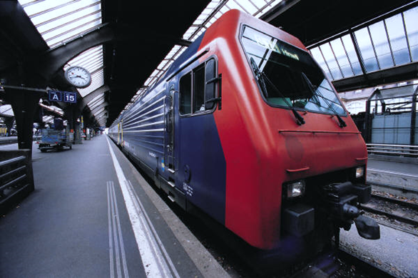

## ABSTRACT

The research project was carried out centered on developing a Help Desk Automated System to increase its efficiency in service delivery by automating all the expertise involved into a computerized system. With this understanding the researcher developed the Help Desk Automated System was crafted. The system brings about the history of Omni Contact as well as its current state. The project emphasizes on the careful and precise reporting of both software and hardware faults encountered by employees right through to the procedure of how te IT technicians will be assigned to attend to the reported faults. To have a more detailed understanding of the system; interviews were conducted; questionnaires were distributed; observations were made and record inspections were done. Through the research, the organization’s value and ability to undertake the project was exposed considering the availability of most of the necessary resources which included time, hardware, software and the human resource. After a close scrutiny of the findings, it was discovered that software development tools to be used included PHP, MySQL database, JavaScript and Google Chrome browser. Basic system functionalities of the current system described using data and process modelling techniques were employed which included data flow diagrams, use case diagrams, entity relationship diagrams, package diagrams and sequence diagrams. Furthermore, design of the new system was described through highlighting menu, interface and output models to be designed. All the logical structures were turned into specific tested instructions executed by computer system. Different change over methods were explored from which one method was selected after considering influencing factors such as risk control, pace of change and need for facilitation of change. A comprehensive user manual was created so that any challenges faced pertaining to how to use the system the users would refer to the manual. The manual compliments the user training that was conducted during the implementation of the system. To take care of user requirements system maintenance will be provided when need arises.

## DECLARATION

I Mzingaye Victor Mpofu, hereby declare that I am the sole author of this project. This project has been created based on the finding of OMNI Contact. Any other organization will have to get in contact for their bespoke system

Signature Date

## APPROVAL

This dissertation title “Help Desk Automated System” by Mzingaye Victor Mpofu meets the regulations for OMNI Contact to test, implement and use it with no copyright infringement

# **CHAPTER 1 : INTRODUCTION**